Screen layout
Video for top left corner of screen will be 320x240. I think SY’s version uses 240x180. I want to make the video bigger. We were limited to 800x600 screen size last time. We can go with a bigger screen size 1280x800. Here is what the screen layout can look like.
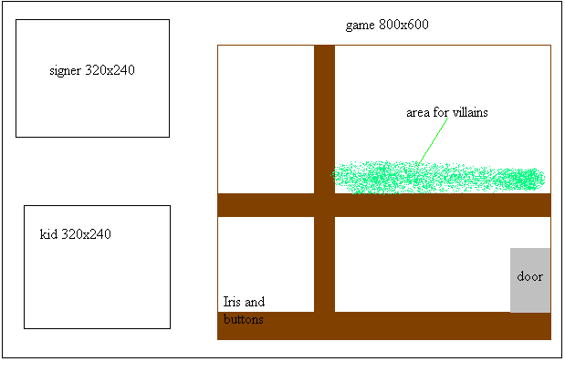
1280x800

The villains should be on the wooden beam in the wall just like I have them in the storyboard.
For the room make the buttons work. The “help” button should pull up video of the signer in the top left corner . The “attention” button should turn Iris (the cat) toward the child so she is looking at the child (this also sends a cue to the sign recognizer that signing will start). The “go” button tells the sign recognizer that signing is finished. If the child signed correctly then play an animation of Iris changing the villain to a monkey (there are various monkeys in shared images, make it so the monkey that appears is random) the gem with the villain should then fly over to the top left corner and then the score should update to one higher. If the child is wrong a question mark appears over Iris’ head. SY’s code should do most of this with a little modification. All the graphics you need should be in the “shared images” folder.
After Iris “poofs’ the villain to become a monkey have Iris run to the door and then the program goes to the maze swf.
Be creative with the visual effect for Iris changing the villain to a monkey. Make it look cool. Any little cool touches you want to add, please do.

Also for the buttons, the number of times the “help” button is pushed is recorded and the number of attempts the child makes for each sentence is recorded. Keep that in this game. SY’s code should do it.

Remember that we want to pull different room backgrounds randomly. In the demo, I made the room game pulls from 5 different room backgrounds.These are swf files
I made the 20 background swf files needed for the real game . They are on this CD.

There is a door animated gif in shared images. Just pull out the one frame where the door is closed to use for the house door.

